|  |  |
| --- | --- |
| Activity 2 - Blink | Group activity |

In the Arduino IDE

* Open the file Arduino -> File -> Examples -> Basics -> Blink.
* Customize the Header Comments.
* Rename and save the sketch to a new location.
* Run the sketch, confirm that the led blinks.

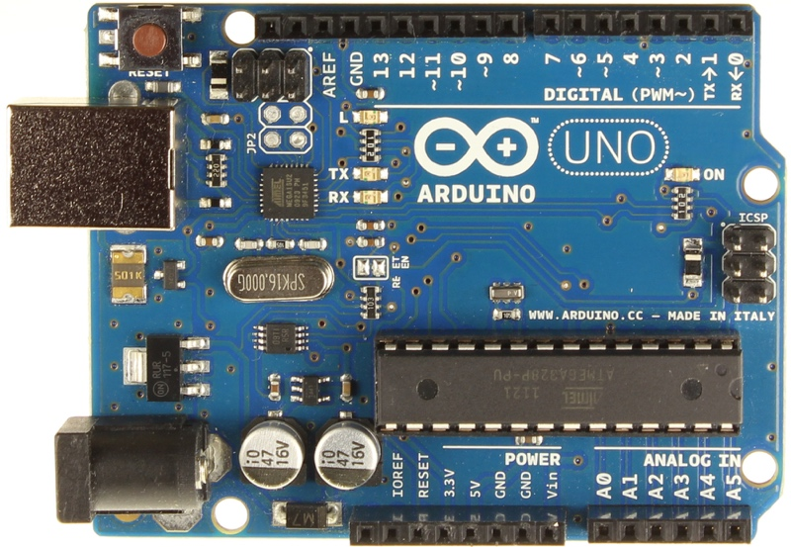

This LED should blink @ ~1Hz